Tripistry
Group 22
Full Names and Student NO:
- Ngeletshedzo Mutwanamba u25039769
- Amira Ajanaku u25111699
- Ntsako Mabasa u25083784
- Livhuwani Munyai u25449029
- Navela Hlungwani 25254686

Task 2: E(ER) Diagram (1st iteration)
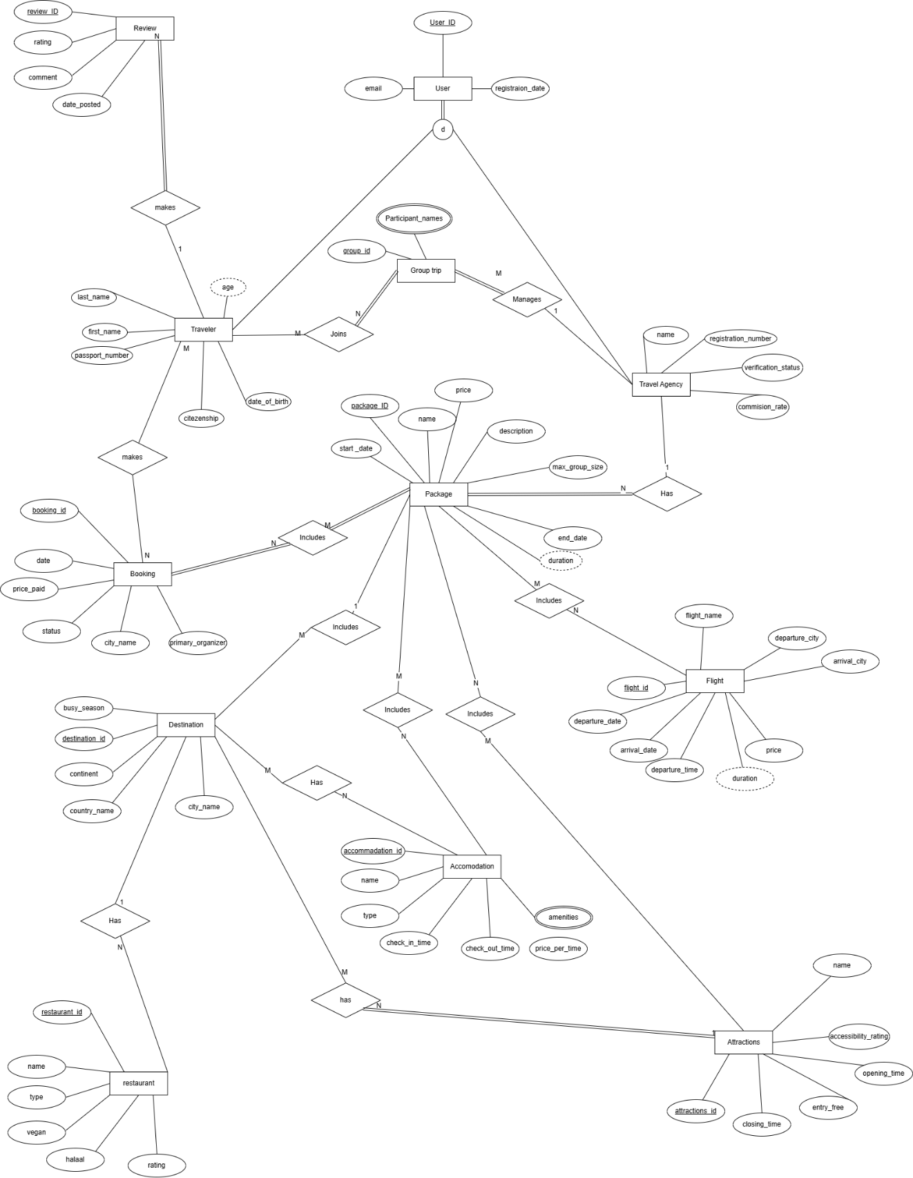
Final E(ER)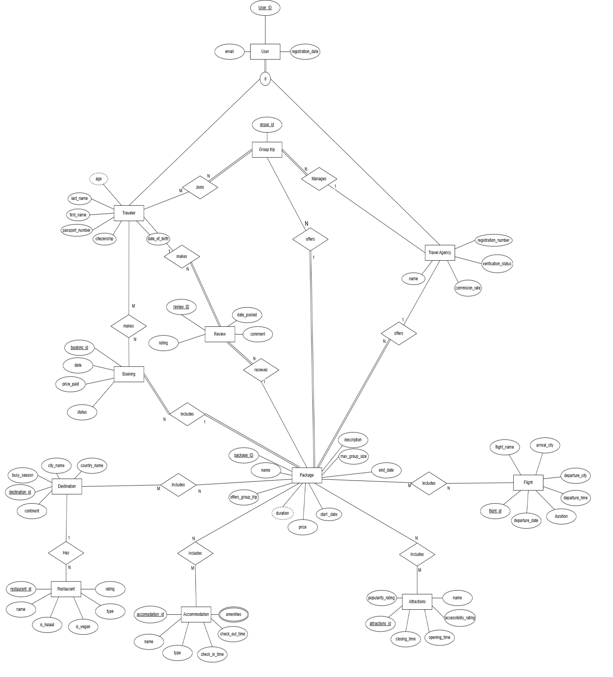

In the initial iteration with the Entity Group_trips, it had an attribute called Participant_names but then it got removed because it was redundant. The final version shows the information about the participant is stored through the M: N relationship between Traveller and Group Trip. The participants names can be retrieved by querying travellers linked to a specific group trip. The entity Review was not integrated well into to the E(ER) diagram and was changed in the second iteration as it has a clearer relationship between Package and Traveller. The relationship changes made were Traveller ->Booking was 1: N and changed to N: M. In the second iteration, an attribute named offers_group_trip was added to the Package entity and the relationship between Package and Group Trip called offers with a cardinality of 1: N.
Task 3: Relational Mapping
Step 1:
For each regular entity type in my conceptual model, I create a relation that includes all simple attributes. Composite attributes are broken down into their simple components.
USER Entity:
User_ID (PRIMARY KEY, INT)
Email (VARCHAR (100))
Registration_date (DATE)
TRAVELLER Entity:
Passport_number (Primary key, VARCHAR (20))
first_name (VARCHAR (100))
last_name (VARCHAR (100))
date_of_birth (DATE)
citizenship ((100))

TRAVEL AGENCY Entity:
registration_number (Primary key, INT)
name (VARCHAR (100))
verification_status (Varchar (20))

GROUP TRIP Entity:
group_id (Primary Key, INT)

DESTINATION Entity:
Destination_id (Primary Key, INT)
City_name (VARCHAR (100))
Country_name (VARCHAR (20))
Busy_season (VARCHAR (20))
Continent (VARCHAR (50))

RESTAURANT Entity:
Restaurant_id(Primary Key, INT)
name (VARCHAR (100))
rating (Decimal (3,1))
type (VARCHAR (50))
is_halaal (BOOLEAN)
is_vegan (BOOLEAN)

ACCOMMODATION Entity:
Accommodation_id (Primary Key, INT)
Name (VARCHAR (100))
Type (VARCHAR (50))
check_in_time (TIME)
check_out_time (TIME)

ATTRACTIONS Entity:
attractions_id (Primary Key, INT)
name (VARCHAR (100))
popularity_rating (Decimal (3,1))
accessibility_rating (Decimal (3,1))
opening_time (TIME)
closing_time (TIME)

FLIGHT Entity:
flight_id (Primary Key, INT)
flight_name (VARCHAR (50))
departure_city (VARCHAR (100))
departure_date (DATE)
departure_time (TIME)
arrival_city (VARCHAR (100))
duration (DECIMAL (4,2))
PACKAGE Entity:
package_ID (Primary Key, INT)
name (VARCHAR (100))
price (DECIMAL (10,2))
start_date (DATE)
end_date (DATE)
description (TEXT)
max_group_size (INT)
duration (DECIMAL (4,2))
offers_group_trip (BOOLEAN)
BOOKING Entity:
booking_id (Primary Key, INT)
date (DATE)
price_paid (DECIMAL (10,2))
status (VARCHAR (20))
REVIEW Entity:
review_ID (Primary Key, INT)
rating (DECIMAL (3,1))
comment (TEXT)
date_posted (DATE)

Step 2: Weak Entities
There are no weak entities in the relational model as all entities have their own primary key, so Step 2 is not applicable.
Step3: Mapping 1:1 Binary relationships
There are no 1:1 relationship in the model.

Step 4: Mapping Binary 1: N relationships
- Each traveller can make many reviews on the packages they have bought
- A Travel Agency can offer multiple packages
- A travel Agency may manage many group trips

Step 5: Mapping Binary M: N relationships
- A traveller can make many bookings, and a booking can be made by many travellers.
- A traveller can join many group trips, and a group trip can be joined by many travellers.
- A package can receive many reviews, and a review can be associated with many packages.
- A booking can include many packages, and a package can be included in many bookings.
- A package can include many destinations, and a destination can be included in many packages.
- A package can include many accommodations, and an accommodation can be included in many packages.
- A package can include many attractions, and an attraction can be included in many packages.
- A package can include many flights, and a flight can be included in many packages.
- A destination can have many restaurants, and a restaurant can belong to many destinations.
Step 6: multivalued attributes
The multivalued attributes amenities from the Accommodation entity. A single accommodation can offer multiple amenities such as Wi-Fi and swimming pools etc.
Step 7: Step 7: Mapping N-ary Relationship
This model does not have N-ary relationships. All relationships involve exactly two entities which makes them binary.

Step 8: Mapping of Specialisation
The specialisation of the User entity into two subclasses which are Traveller and Travel Agency. The specialisation is total and disjoint, and this is shown by using the ‘d’ notation. This means that a User can only be either a traveller or a travel agency. We kept three separate tables: one for User, one for Traveller and one for Travel Agency. Both types share information that is stored in the User table. They both se User_ID as their primary key and that links back to User table. We did it this way so that the same information is not stored more than once.
Step 9: Mapping Unions
there are no unions in our model.

TASK 4: Relational Schema
Tables
USE tripistry; SHOW TABLES;
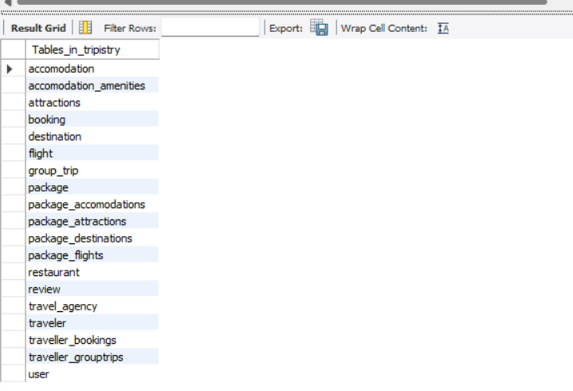
Structure of each table:
DESCRIBE user;
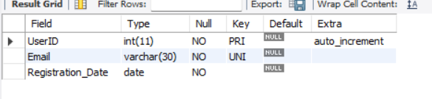
DESCRIBE traveler;
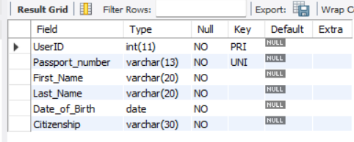

DESCRIBE travel_agency;
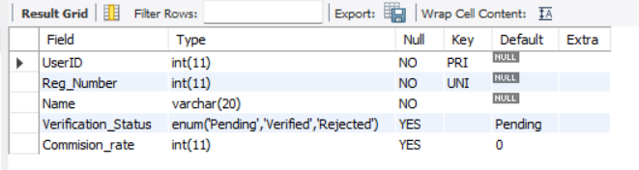

DESCRIBE destination;
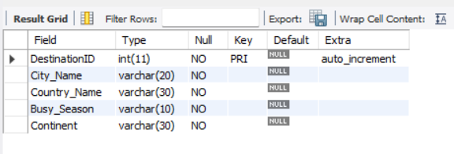
DESCRIBE accomodation;
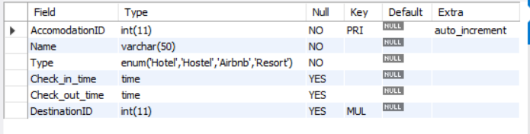
DESCRIBE accomodation_amenities;
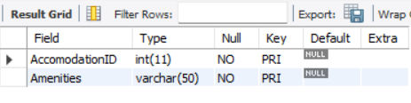

DESCRIBE attractions;
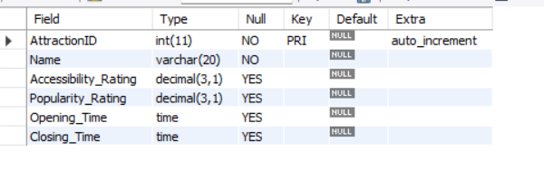
DESCRIBE restaurant;
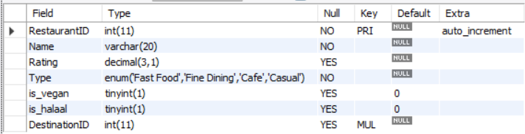
DESCRIBE flight;
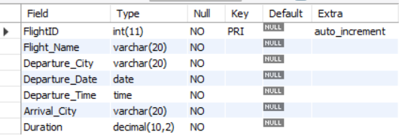

DESCRIBE package;
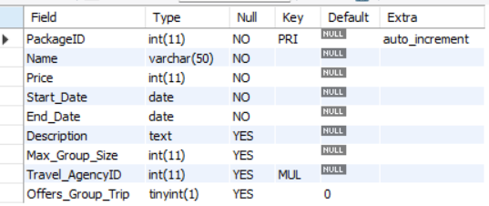
DESCRIBE booking;
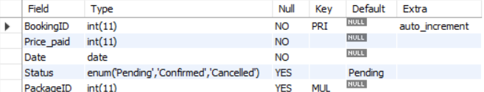
DESCRIBE review;
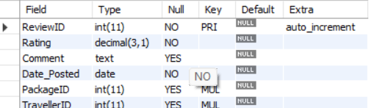

DESCRIBE group_trip;
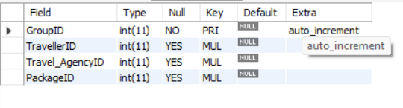

DESCRIBE package_destinations;
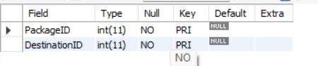

DESCRIBE package_accomodations;
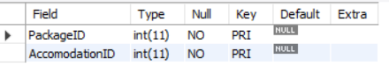
DESCRIBE package_attractions;
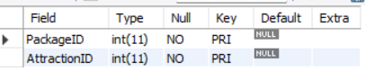
DESCRIBE package_flights;
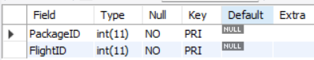
DESCRIBE traveller_bookings;
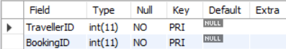
DESCRIBE traveller_grouptrips;
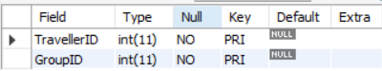

SHOWING constraints, checks and foreign keys

SHOW CREATE TABLE user;
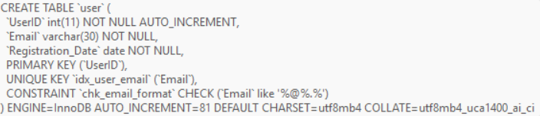

SHOW CREATE TABLE traveler;
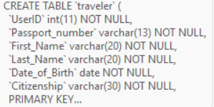
SHOW CREATE TABLE travel_agency;
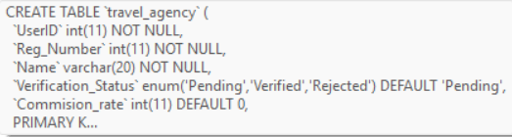
SHOW CREATE TABLE destination;
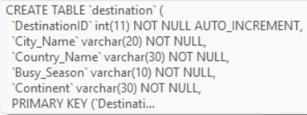
SHOW CREATE TABLE accomodation;
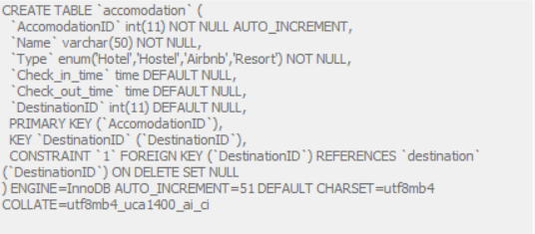

SHOW CREATE TABLE accomodation_amenities;
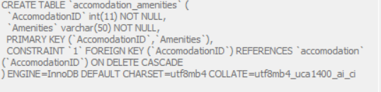
SHOW CREATE TABLE attractions;
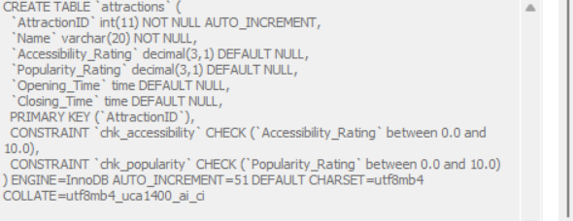

SHOW CREATE TABLE restaurant;
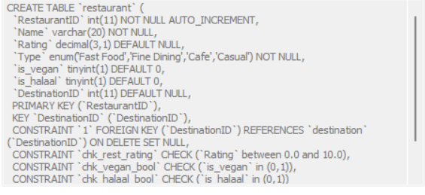

SHOW CREATE TABLE flight;
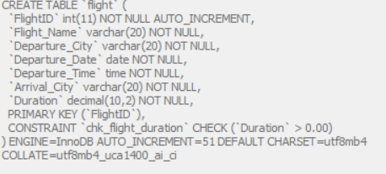

SHOW CREATE TABLE package;
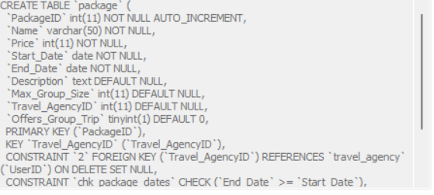
SHOW CREATE TABLE booking;
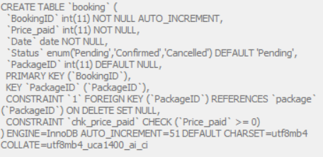
SHOW CREATE TABLE review;
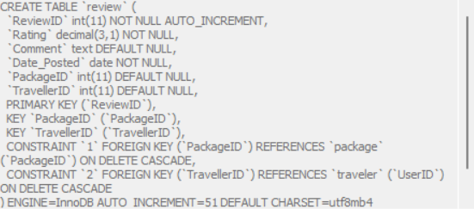
SHOW CREATE TABLE group_trip;
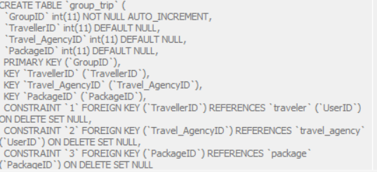
SHOW CREATE TABLE package_destinations;
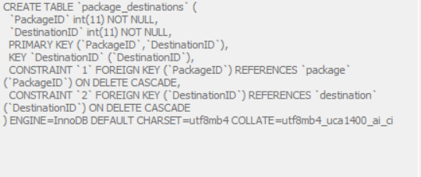

SHOW CREATE TABLE package_accomodations;
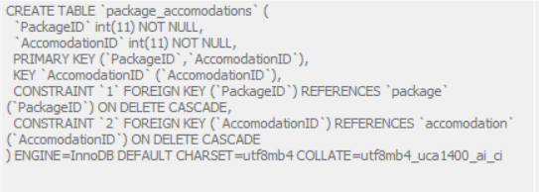
SHOW CREATE TABLE package_attractions;
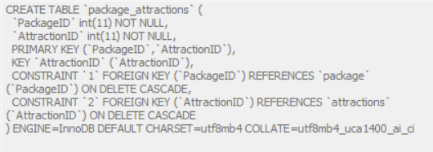
SHOW CREATE TABLE package_flights;
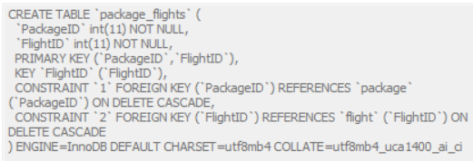
SHOW CREATE TABLE traveller_bookings;
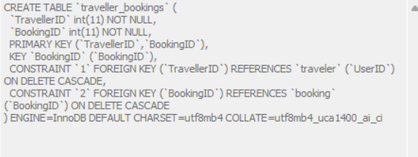
SHOW CREATE TABLE traveller_grouptrips;
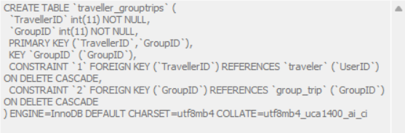
ALL FOREIGN KEYS
SELECT TABLE_NAME, COLUMN_NAME, CONSTRAINT_NAME, REFERENCED_TABLE_NAME, REFERENCED_COLUMN_NAME
FROM INFORMATION_SCHEMA.KEY_COLUMN_USAGE
WHERE REFERENCED_TABLE_NAME IS NOT NULL AND TABLE_SCHEMA = 'tripistry'
ORDER BY TABLE_NAME;
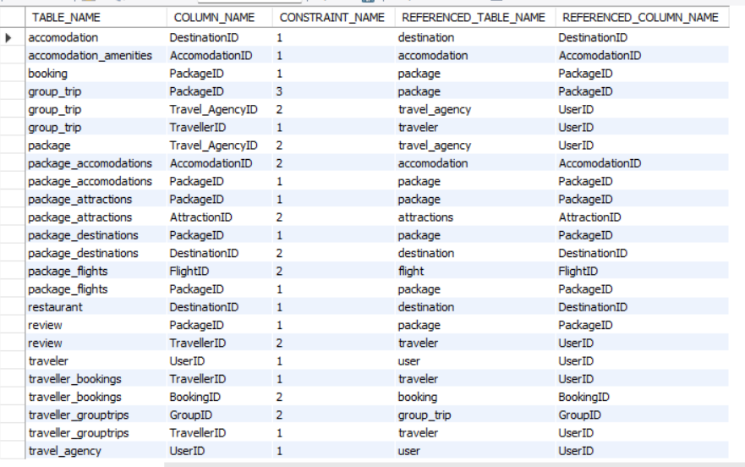

TASK 6: DATA
We have chosen to populate the database by manually using SQL INSERT statements by hand. All destination names, attractions, flight routes and accommodation names were researched from sources such as TripAdvisor, Booking.com and FlightAware. We chose this method because we could oversee what data went into each table in the database and that made it easier to correct any errors we encountered. We did not use the option of fetching data from an API because some APIs may have some missing data and that may be difficult to fix. We did not want to use fake data or generate fake data as it would not make the website realistic. Though this method may have taken more time, it was a more reliable option. The database has 50 records in each table and 35 groups and 30 travel agencies.

TASK 7: ANALYSE AND OPTIMISE
Query 1:
SELECT p.PackageID, p.Name, p.Description, p.Price,
p.Start_Date, p.End_Date, p.Max_Group_Size,
DATEDIFF(p.End_Date, p.Start_Date) AS Duration,
t.Name AS AgencyName,
COALESCE(AVG(r.Rating), 0) AS AvgRating,
COUNT(DISTINCT r.ReviewID) AS ReviewCount
FROM package AS p
LEFT JOIN travel_agency AS t ON p.Travel_AgencyID = t.UserID
LEFT JOIN review AS r ON p.PackageID = r.PackageID
WHERE p.PackageID = 1
GROUP BY p.PackageID, p.Name, p.Description, p.Price,
p.Start_Date, p.End_Date, p.Max_Group_Size, t.Name;

1.THE INTIAL PERFORMANCE EVALUATION
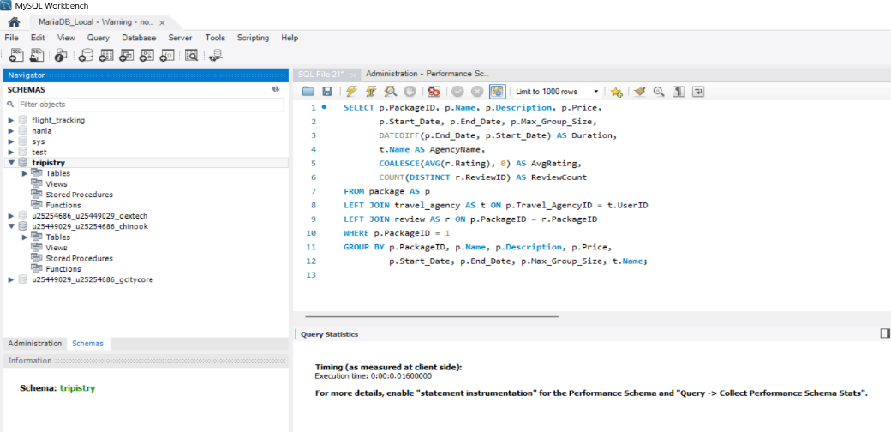
The initial execution time on our database was 0.01600000 seconds. In this state, the database engine had to look at all the existing rows in the review table sequentially to find the matches for PackageID = 1 to process the LEFT JOIN and aggregations.

2 . To optimize the this specific data retrieval layout, an index was explicitly created on the foreign key column of our review table using this query:
CREATE INDEX idx_review_package ON review(PackageID);
3. AFTER-OPTIMIZATION
After the creation of the index, the query execution time was 0.0000000 seconds. The execution time decreased by 0.01600000 seconds, bringing the query to near-instantaneous reading.
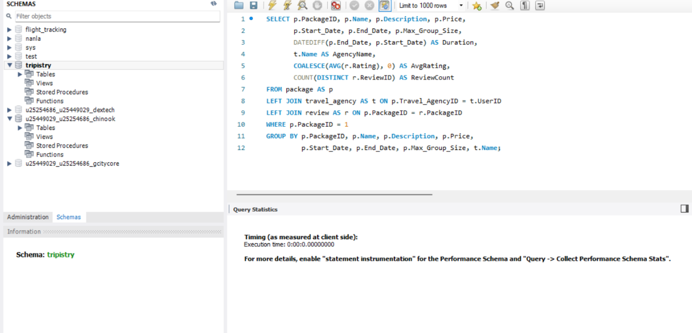

4. CONCLUSION
When the index idx_review_package was implemented, it formed a direct pointer map for the rows. Instead of scanning through all the rows sequentially to find matching review data for the package, the database engine used the index to immediately target the exact rows needed for the AVG and COUNT functions, completely eliminating the baseline structural delay.

Query 2:
SELECT DISTINCT r.RestaurantID, r.Name, r.Type,
r.Rating, r.is_vegan, r.is_halaal
FROM restaurant AS r
JOIN destination AS d ON r.DestinationID = d.DestinationID
JOIN package_destinations AS pd ON d.DestinationID = pd.DestinationID
WHERE pd.PackageID = 10;

1.THE INTIAL PERFORMANCE EVALUATION
The initial execution time on our database was 0.01600000 seconds. In this initial state, the database engine had to read through the data sequentially to handle the table links and execute the SELECT DISTINCT filter. Without an index on the package_destinations.PackageID column, the engine had to look at all existing rows in that junction table to isolate the matches for PackageID = 10.
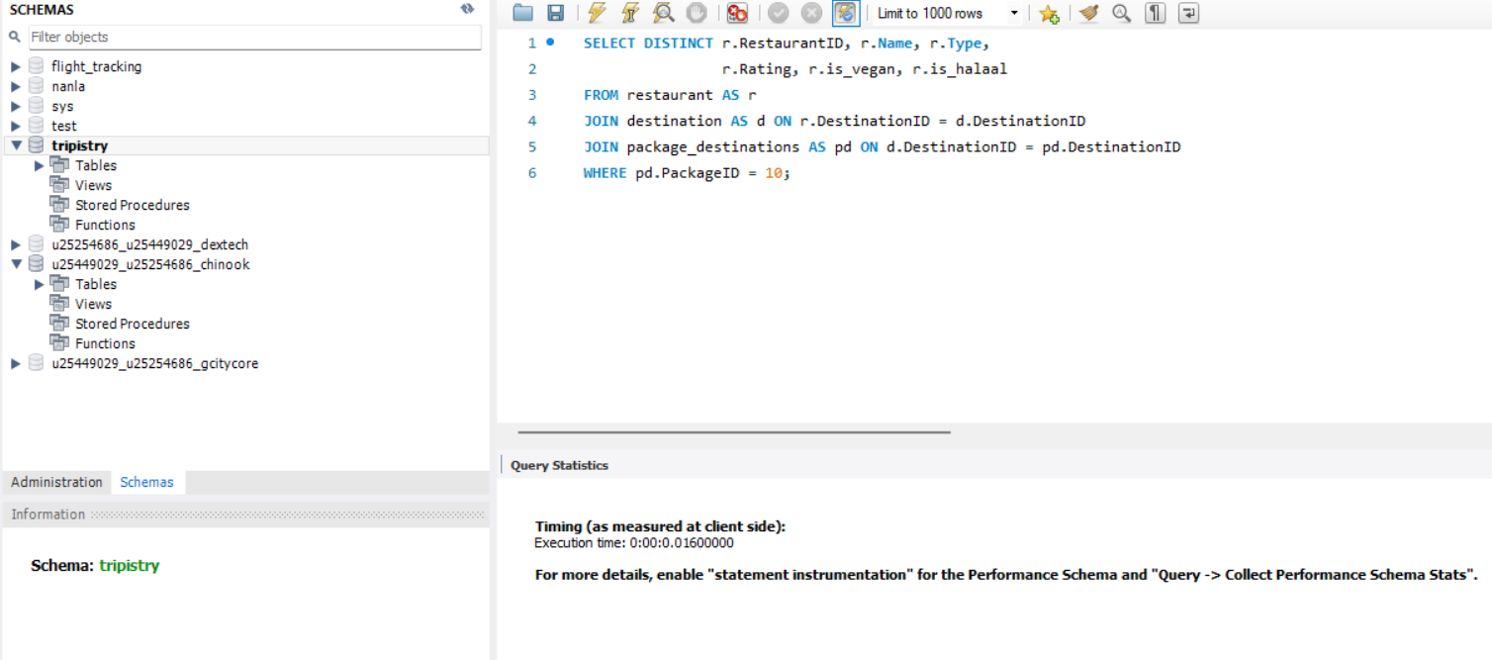
2 . To optimize the this specific layout and accelate the filtering process during multi-table join, an index was explicitly created on the foreign key column of our review table using this query:
CREATE INDEX idx_package_dest_package ON package_destinations(PackageID);

3. AFTER-OPTIMIZATION
After the creation of the index, the query execution time was 0.0000000 seconds. The execution time decreased by 0.01600000 seconds, bringing the query to near-instantaneous reading.
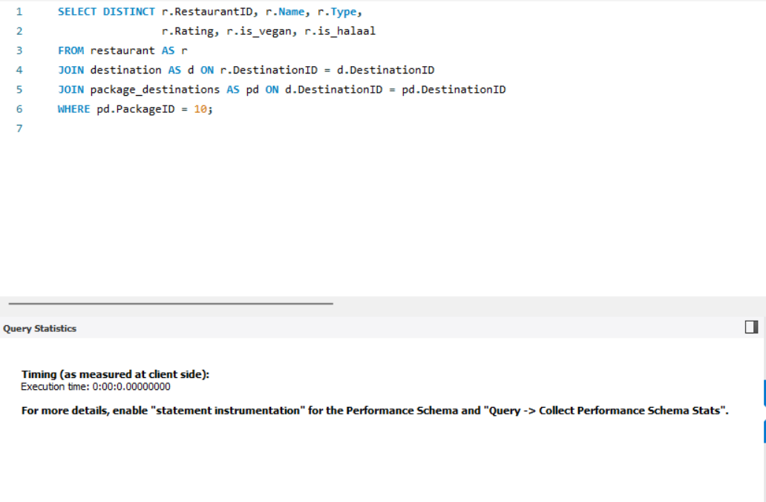
4. CONCLUSION
When the index idx_package_dest_package was implemented, it formed a direct pointer map for the rows. Instead of scanning through all the rows sequentially within the package_destinations table to find matching data for the requested package, the database engine used the index to immediately target the exact rows needed for the subsequent destination and restaurant connections. Because the search path shifted from a sequential scan directly to a targeted index reference, the processing overhead was removed, dropping the recorded client-side execution time down to 0 milliseconds.

TASK 8:
Github link
ngeletech/NanlaPA5

